ESE 471 Assignment #2

Channel Encoding: Error Correction

Assigned Date: February 20, 2017

Due Date: March 1, 2017 in class.

The following is a conceptual diagram of the communication system, which we have talked about extensively in class.



In particular, for the baseband communication systems (Chapter 3), the transmitter block shown above can be expanded to:

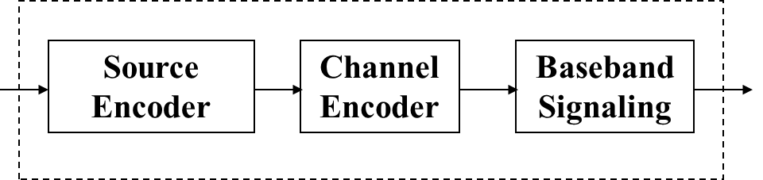

Note that the source encoder shown above is what your group has experimented during the previous assignment. That is, your group came up with a source encoded binary file for the NY Times article, which your group believes to represent the original NY Times article efficiently.

In this assignment, your group will tackle the second box shown in the figure above, namely the channel encoder. As I have explained during the lecture, the channel encoder converts the output from the source encoder to match the requirements imposed by the channel, such as to provide reliable communication in the presence of errors. Errors are unavoidable in all realizable channels, no exception.

Suppose that the transmitter sends 0110101 across a channel. Because the condition of the channel is poor, an error takes place and the receiver receives 0110111 instead. That is, one of the transmitted 0s becomes 1 as it is underlined in the received sequence. FYI, in today’s cellular wireless channels, about 1% of the transmitted bits are received in error during a normal operation.

To combat the errors, the channel encoder may perform error correction encoding, commonly known as the forward error correction (FEC). As an example, the channel encoder may triplicate each bit generated by the source encoder. Using the above example, the bit sequence 0110101 is channel encoded as 000111111000111000111. By sending 000111111000111000111, if any one bit is in error, e.g., 000111111000111010111 (underscored), the receiver recognizes this error since there have to be three identical bits in a row (either 000 or 111) as each source encoded bit is triplicated by the channel encoder before sending it over the channel. Then using a simple majority reasoning, the receiver corrects the single error bit such that the received bit sequence becomes 000111111000111000111. This example shows a type of FEC known as the repetition coding. Note that if one bit among the three triplicated bits is in error, the receiver can correct it. If, however, two or three bits among the triplicated bits is in error, the receiver cannot correct the errors.

To do:

Your group will use the NY Times article from the last assignment, which your group has source-encoded. This source encoded article is then be channel encoded using the repetition code explained above, i.e., each bit is triplicated. Your group will experiment that each channel encoded bit becomes an error with probability p = 0.01, 0.05, 0.1. (For this, use a random number generator, e.g., function “rand” in Matlab, to determine whether each bit is in error.) Then, apply the majority reasoning explained above and correct the errors. Note that not all of the errors may be corrected. Determine the percentage of the source encoded bits that are not corrected. Then, take the next step to convert the error corrected source encoded bits into the form of information that the digital source used, i.e., pre-source encoded. Since not all of the source encoded bits may be correctly received, you may not get the exact NY Times article. Determine the percentage of the symbols in error in the NY Times article. These percentages will show the effectiveness of your transmitter.